Blackboard Grade Center: Check for Duplicate and Hidden Columns
The only columns you should have in your grade center are graded activities for the current semester. Duplicate columns can impact students’ grades and lead to grade center issues for instructors as well. To be fully transparent and fair in grading, no graded columns should ever be hidden from students.

Follow these steps to doublecheck your grade center columns.

- Go to the Full Grade Center in a course.
- Click on the Manage drop-down menu near the top.
- Select Column Organization.
- On the Column Organization page, you will see a complete listing of every column in your gradebook.
- Make sure that you do not have any duplicate or hidden columns (besides the Last Date of Activity column, which can remain hidden since it is not a graded item). 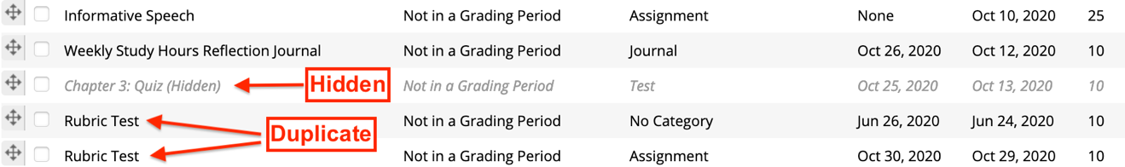
  - If you have duplicate columns, take care in deleting the appropriate item. Blackboard may prevent you from removing items. If you are unsure or have difficulty deleting a column, contact an instructional designer.
  - If you have hidden columns, you can unhide them from the Column Organization page by checking the box next to the name and clicking the Show/Hide button.
  - If you are unable to delete a column for some reason and therefore want it to be hidden to avoid student confusion, make sure you edit the settings and exclude it from grade center calculations.
Need Help?
Contact one of our instructional designers.

